Romano's Pizza Group
Sales Behaviour Analysis

1. Project Overview
This project analyses pizza sales behaviour using transactional data from 48,620 orders across various pizza categories, sizes and time periods. The goal is to uncover insights into revenue patterns, peak trading hours, product performance and customer ordering behaviour to guide strategic business and operational decisions for Romano's Pizza Group.

2. Dataset Summary
- Rows: 48,620
- Columns: 15 (after cleaning)
- Key Features:
- Order details (pizza_id, order_id, quantity, unit_price, total_price)
- Product details (pizza_name, pizza_category, pizza_size)
- Time details (order_date, order_time, month, month_name, day_of_week, quarter, hour)
- Missing Data: Zero null values after cleaning

3. Exploratory Data Analysis using Python
We began with data preparation and cleaning in Python using Google Colab:

- Data Loading: Imported the dataset using pandas

- Initial Exploration: Used df.info() to check structure and df.describe(include="all") for summary statistics
df.describe(include = “all”)
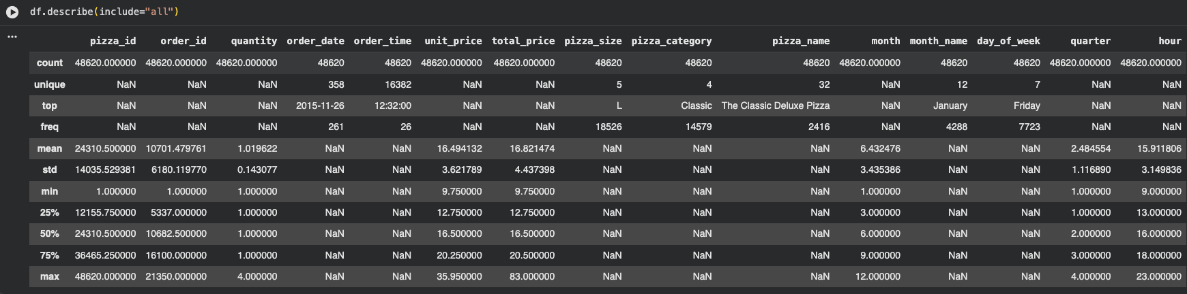

df.info() output:
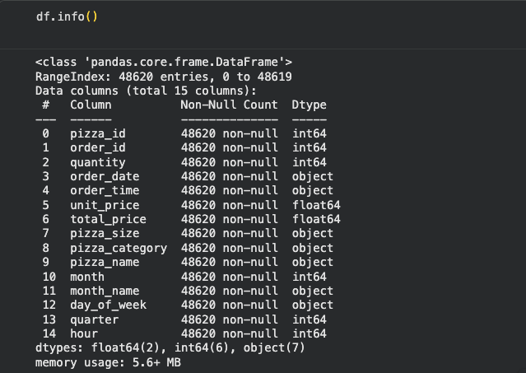

- Data Type Issues Found: pizza_id, order_id and quantity were stored as float64 and converted to int64 using .astype(int)

- Mixed Date Formats: order_date column had two different formats mixed together — MM/DD/YYYY (19,587 rows) and DD-MM-YYYY (29,033 rows). Resolved using pd.to_datetime(format='mixed', dayfirst=False)

- Time Column Fix: order_time was stored as plain text. Converted to datetime using pd.to_datetime(format='%H:%M:%S') then extracted the hour column

- Feature Engineering:
- Created month and month_name columns from order_date
- Created day_of_week column from order_date
- Created quarter column from order_date
- Created hour column from order_time

- Redundant Columns Dropped: pizza_name_id was a duplicate slug of pizza_name and pizza_size combined. pizza_ingredients was not required for any business query. Both were dropped.

- Data Validation: Verified zero null values, zero duplicate rows, and confirmed total_price matched unit_price x quantity across all 48,620 rows

- Database Integration: Connected Python to PostgreSQL via Docker and loaded the cleaned DataFrame into the database for SQL analysis

4. Data Analysis using SQL
We performed structured analysis in PostgreSQL hosted via Docker to answer 11 key business questions:

1. Total Revenue
SELECT ROUND(SUM(total_price),2) AS total_revenue FROM pizza_sales;

total_revenue
$817,860.05

2. Total Orders
SELECT COUNT(DISTINCT order_id) AS total_orders FROM pizza_sales;

total_orders
21,350

3. Total Pizzas Sold
SELECT SUM(quantity) AS total_pizza_sold FROM pizza_sales;

total_pizza_sold
49,574

4. Average Order Value
SELECT ROUND(SUM(total_price)/COUNT(DISTINCT order_id),2) AS avg_order_value FROM pizza_sales;

avg_order_value
$38.31

5. Revenue by Month
SELECT month, month_name, ROUND(SUM(total_price),2) AS total_revenue_monthly
FROM pizza_sales GROUP BY month, month_name ORDER BY month;

Month | Month Name | Revenue
1 | January | $69,793
2 | February | $65,159
3 | March | $70,397
4 | April | $68,736
5 | May | $71,402
6 | June | $68,230
7 | July | $72,557
8 | August | $71,797
9 | September | $66,642
10 | October | $67,431
11 | November | $70,395
12 | December | $61,275

6. Orders by Day of Week
SELECT day_of_week, COUNT(DISTINCT order_id) AS total_order_by_day_of_week
FROM pizza_sales GROUP BY day_of_week ORDER BY total_order_by_day_of_week DESC;

Day of Week | Total Orders
Friday | 3,538
Thursday | 3,239
Saturday | 3,158
Wednesday | 3,024
Tuesday | 2,973
Monday | 2,794
Sunday | 2,624

7. Orders by Hour
SELECT hour, COUNT(DISTINCT order_id) AS total_order_by_hour
FROM pizza_sales GROUP BY hour ORDER BY hour;

Hour | Total Orders
9am | 1
10am | 60
11am | 857
12pm | 2,520
1pm | 2,455
2pm | 778
3pm | 794
4pm | 1,472
5pm | 2,336
6pm | 2,399
7pm | 2,009
8pm | 1,642
9pm | 1,198
10pm | 663
11pm | 192

8. Top 5 Pizzas by Revenue
SELECT pizza_name, ROUND(SUM(total_price),2) AS revenue
FROM pizza_sales GROUP BY pizza_name ORDER BY revenue DESC LIMIT 5;

Pizza Name | Revenue
The Thai Chicken Pizza | $43,434
The Barbecue Chicken Pizza | $42,768
The California Chicken Pizza | $41,409
The Classic Deluxe Pizza | $38,180
The Spicy Italian Pizza | $34,831

9. Bottom 5 Pizzas by Revenue
SELECT pizza_name, ROUND(SUM(total_price),2) AS revenue
FROM pizza_sales GROUP BY pizza_name ORDER BY revenue ASC LIMIT 5;

Pizza Name | Revenue
The Brie Carre Pizza | $11,588
The Green Garden Pizza | $13,955
The Spinach Supreme Pizza | $15,277
The Mediterranean Pizza | $15,360
The Spinach Pesto Pizza | $15,596

10. Revenue by Pizza Category
SELECT pizza_category, ROUND(SUM(total_price),2) AS total_revenue_pizza_category
FROM pizza_sales GROUP BY pizza_category ORDER BY total_revenue_pizza_category DESC;

Category | Revenue
Classic | $220,053
Supreme | $208,197
Chicken | $195,919
Veggie | $193,690

11. Revenue by Pizza Size
SELECT pizza_size, ROUND(SUM(total_price),2) AS total_revenue_pizza_size
FROM pizza_sales GROUP BY pizza_size ORDER BY total_revenue_pizza_size DESC;

Size | Revenue
L (Large) | $375,318
M (Medium) | $249,382
S (Small) | $178,076
XL | $14,076
XXL | $1,006

5. Customer Behaviour Dashboard in Google Looker Studio
Dashboard Title: Romano's Pizza Group Sales Behaviour Analysis
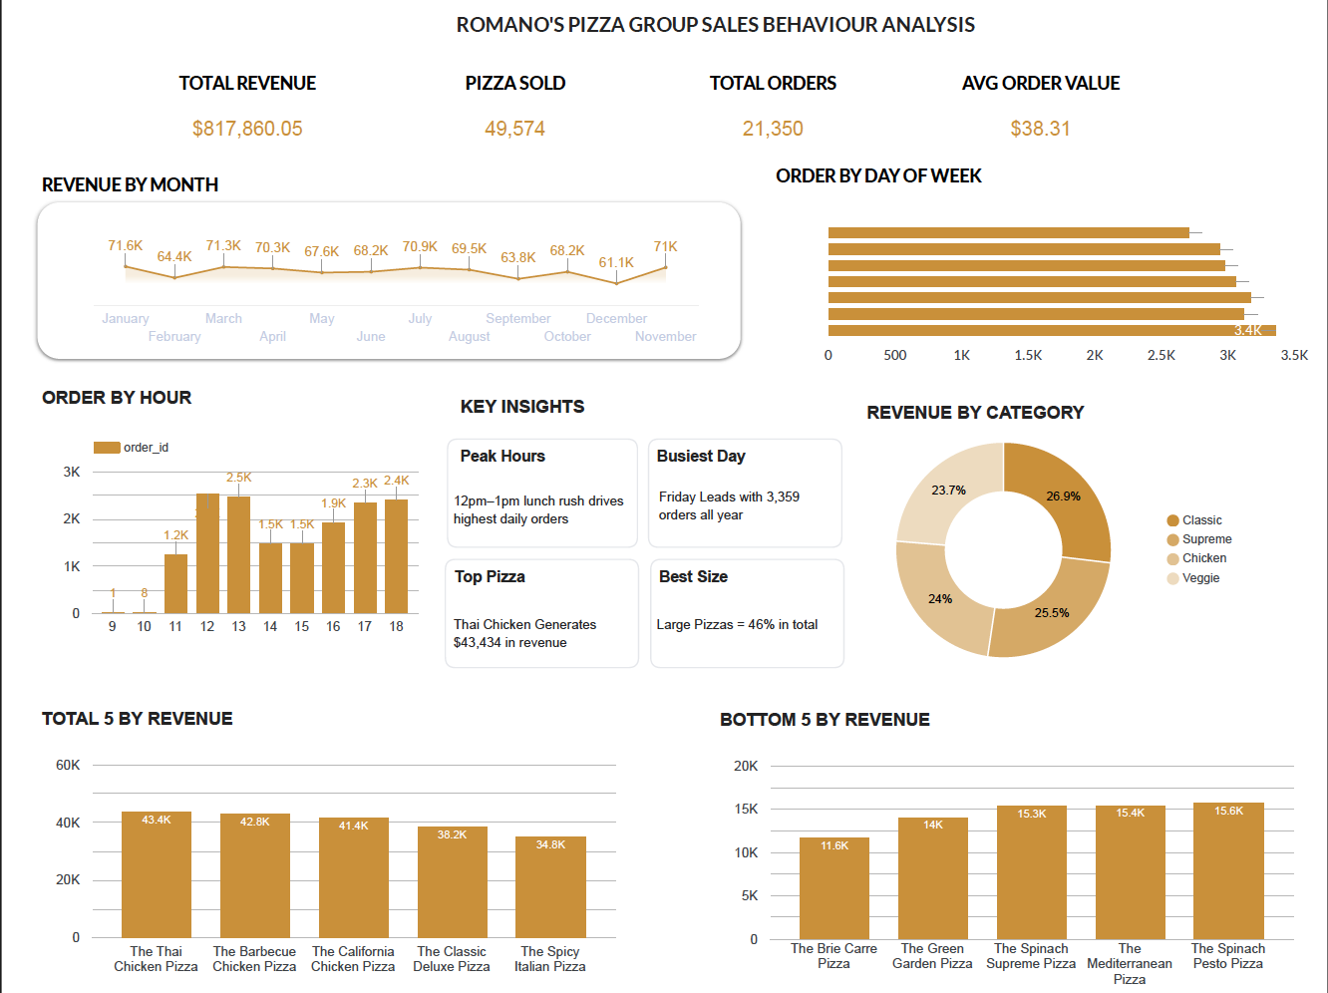

6. Business Recommendations

- Staff for Peak Hours — Increase staffing during 12pm to 1pm lunch rush and 5pm to 7pm dinner window which drive the highest daily order volumes

- Prioritise Fridays — Friday is the single busiest day with 3,538 orders. Ensure maximum staff availability and ingredient stock every Friday.

- Promote Top Pizzas — The Thai Chicken, BBQ Chicken and California Chicken are the top 3 revenue generators and should be actively featured in promotions and marketing campaigns

- Review Bottom Performers — The Brie Carre Pizza generates only $11,588 for the full year and should be considered for removal or discounted promotion to drive volume

- Remove XXL Size — XXL generates only $1,006 across the entire year suggesting extremely low demand. Removing it simplifies operations and reduces waste

- December Promotions — December records the lowest monthly revenue at $61,275 compared to July peak of $72,557. A targeted promotional campaign in December could bridge this gap

- Focus on Large Size — Large pizzas account for 46% of total revenue. Upselling Medium customers to Large through combo deals could significantly increase average order value

- Invest in Classic Category — Classic pizzas lead all categories at $220,053 and 27% of total revenue. Expanding the Classic range or adding seasonal Classic variants could grow this further

